A project report

On

Travel Mate

Submitted in partial fulfillment of the requirement of Project – V BIT378CO

Of

Bachelor of Information Technology

**Submitted to**



Purbanchal University

Biratnagar, Nepal

**Submitted By**

Milan Manandhar (353564)

Raman Koju (353568)

Rojay Awale (353570)

**KANTIPUR CITY COLLEGE**

Putalisadak, Kathmandu

23rd January, 2021

A project report

On

Travel Mate

Submitted in partial fulfillment of the requirement of Project – V BIT378CO

Of

Bachelor of Information Technology

**Submitted to**

Purbanchal University

Biratnagar, Nepal

**Submitted By**

Milan Manandhar (353564)

Raman Koju (353568)

Rojay Awale (353570)

**Project Supervisor**

**Mr. Prakash Gautam**

**KANTIPUR CITY COLLEGE**

Putalisadak, Kathmandu

23rd January, 2021

**TOPIC APPROVAL SHEET**

It is hereby informed that the topic selected by Milan Manandhar, Raman Koju and Rojay Awale of BIT V semester for their semester project has been found suitable and as per the credit assigned by Purbanchal University (PU), Biratnagar, Nepal.

The project Committee has approved the following topic for the above-mentioned students.

Topic Approved: TravelMate

|  |  |  |
| --- | --- | --- |
| ________________ |  | __________________ |
| Ashim KC |  | Bikash Neupane |
| Coordinator BCA, BIT |  | Project Coordinator |

**CERTIFICATE FROM THE SUPERVISOR**

This is to certify that the project entitled “TravelMate” submitted by Raman Koju, Milan Manandhar and Rojay Awale to the department of Information Technology, School of Science and Technology at Kantipur City College, Kathmandu, Nepal towards the requirement for BIT378CO of is an original work carried out by them under my supervision and guidance.

Signature:

________________________

Mr. Prakash Gautam

Project Supervisor

Place: Kantipur City Collage, Putalisadak Kathmandu

Date: 23rd January, 2021

# ACKNOWLEDGEMENT

We would like to express our deepest appreciation to all those who provided us the possibility to complete this report. We would like to acknowledge with much appreciation the crucial role of the staff of Kantipur City Collage, who gave us the permission to use all required equipment and the necessary materials to complete the task.

Furthermore, special thanks to our project supervisor, Mr. Prakash Gautam, whose contribution in stimulating suggestions and encouragement, helped us to coordinate our project especially in writing this report also suggesting us about the task and guiding us during the completion of this project. Finally, many thanks to lab in-charge for providing the facilities of lab during our project. We must appreciate the guidance given by other supervisor as well as the panels especially in our project presentation that has improved our presentation skills, thanks to their comment and advices.

# ABSTRACT

This project is basic example of how Hotel searching and recommendation system works. It helps users to find appropriate hotel rooms at distant places even before visiting. This kind of system reduces traveler’s problem of accommodation. The best thing about this system is that, it allows users to provide a feedback about their experience with hotel which helps other users and also forces hotel owners for better services to customers.

This system is beneficial to customers and hotels. Customers can find hotels as per their requirements using search function and feedback system. Hotel owners can also benefit from this system as their reach increases to distant parts of the world.

**TABLE OF CONTENTS**

ACKNOWLEDGEMENT I

ABSTRACT II

LIST OF FIGURES iii

LIST OF TABLES iv

ABBREVIATIONS v

Chapter 1: INTRODUCTION 1

1.1 Project introduction 1

1.2 Problem Statement 1

1.3 Objective of the project 1

1.4 Significance of the project 2

1.5 Features of the project 2

1.6 Assignment of Roles 2

1.7 Documentation Organization 3

Chapter 2: Existing System’s Overview 4

2.1 Overview of Existing System 4

2.2 Limitation of Existing System 4

Chapter 3: System Analysis 5

3.1 System Development Model 5

3.2 Requirement Analysis 5

3.2.1 Functional requirement 6

3.2.2 Non-Functional requirement 6

3.3 Feasibility Study 6

3.3.1 Technical feasibility 6

3.3.2 Schedule feasibility 7

3.3.3Economic feasibility 7

3.4 Gantt chart 7

Chapter 4: SYSTEM DESIGN 8

4.1 Context Level Diagram 8

4.2 Level 0 DFD 9

4.3 Level 1 DFD 10

4.4 Use Case Diagram 11

4.5 ER Diagram 12

CHAPTER 5: SYSTEM DEVELOPMENT AND IMPLEMENTATION 13

5.1 PROGRAMMING PLATFORM 13

5.1.1 FRONTEND PLATFORM 13

5.1.2 BACKEND PLATFORM: 13

5.2 OPERATING REQUIREMENT 13

5.2.1 Hardware Details 13

5.2.2 Software Details 13

5.3 Testing and Debugging 13

CHAPTER 6: CONCLUSION AND FUTURE ENHANCEMENT 15

6.1 Project Limitation 15

6.2 Conclusion 15

6.3 Future Enhancement 15

REFERENCES 16

APPENDIX 17

|  |  |  |  |  |  |  |  |  |  |  |  |  |  |  |  |  |  |  |  |  |  |  |  |  |  |  |
| --- | --- | --- | --- | --- | --- | --- | --- | --- | --- | --- | --- | --- | --- | --- | --- | --- | --- | --- | --- | --- | --- | --- | --- | --- | --- | --- |
| |  |  |  | | --- | --- | --- | | **Figure no.** | **Figure** | **Page no.** | | 3.1 | System Development Model | 5 | | 3.2 | Gantt Chart | 7 | | 4.1 | Context Diagram | 8 | | 4.2 | Level 0 DFD | 9 | | 4.3 | Level 1 DFD | 10 | | 4.4 | Use Case Diagram | 11 | | 4.5 | E-R Diagram | 12 | |  |  |

# LIST OF FIGURES

# LIST OF TABLES

|  |  |  |  |  |  |  |  |  |  |  |  |  |  |  |
| --- | --- | --- | --- | --- | --- | --- | --- | --- | --- | --- | --- | --- | --- | --- |
| |  |  |  | | --- | --- | --- | | **Table Number** | **Table Name** | **Page Number** | | 1 | Assignment of Roles | 2 | | 2 | Documentation Organization | 3 | | 3 | Testing & Debugging | 13, 14 | |  |  |

# 

# ABBREVIATIONS

|  |  |
| --- | --- |
| **Abbreviation** | **Meaning** |
| CSS | Cascading Style Sheet |
| DFD | Data Flow Diagram |
| ER | Entity Relationship |
| HTML | Hyper Text Markup Language |
| PHP | Hypertext Preprocessor |
| SQL | Structured Query Language |
| TM | Travel Mate |

# Chapter 1: INTRODUCTION

## Project introduction

The TravelMate website provides information on all of the hotels nearby, recommending various hotels on various places around the country. However with this it will get easier to the travelers who wants to know about the hotels with various services and helps to accommodation before they reach the destination.

Thus our project is mainly based on helping the travelers and researchers, to know about different hotels based on their reviews and rating. The system is easy to operate and no special training is needed.

Admin can add, delete, update, edit the data that s/he wants to and users accessing the web can review and rate the hotels if they want. It helps the travelers to accommodation before they reach the destination.

## Problem Statement

In today’s world with the increase in human civilization the no. of people travelling has been increasing, they want to explore new places. Our project mainly focuses in giving knowledge about the different hotels available based on their budget , help to accommodation for travelers and gives knowledge on the features available of that hotel which prevent them from being scammed. This is the reason we present our project “Travel Mate” which helps recommending hotels to the travelers.

## Objective of the project

* Making travel a lot easy.
* Saving the time for travelers.
* Encourage the tourism market.
* Provide a high standard of services suitable for individuals seeking relaxing, comfortable and memorable experiences in the hospitality and tourism industry
* To make research and study easier.
* To make user friendly by minimizing user efforts and making easy operation

## Significance of the project

* This platform reduces time consumption, misunderstandings, and data repetition.
* To save time and increase accuracy in work.
* Simplifies the task and reduces the paper work.
* This system is useful for those people who visit new places quite often.
* People can easily decide whether the hotel is good or bad by using this application.
* Using Collaborative filtering, user will get recommendations of hotels.
* User can decide which hotel to accommodate before they reach the place.
* Other hotels can advertised on our website.

## Features of the project

* New users can register easily providing username and password.
* Administrative authorization provided to add, delete or modify records.
* Search for hotels through city name and their max budget as well.
* Short description about hotel giving information on its whereabouts will be provided.
* Reviews and stars-based rating from different users are provided.
* Users are also able to search for hotels through maximum budget filter.

## Assignment of Roles

|  |  |  |
| --- | --- | --- |
| Team Member | Symbol. no | Task Done |
| Milan Manandhar | 353564 | contribution in coding, interface designing, dataflow diagram, design, documentation, database, requirement gathering, information gathering |
| Raman Koju | 353568 | contribution in Dataflow diagrams, ER diagram, concept, requirement gathering, documentation, presentation |
| Roje Awale | 353570 | Contribution in interface designing, documentation, requirement gathering, presentation, information gathering |

## Documentation Organization

|  |  |  |
| --- | --- | --- |
| Chapters | Heading | Contains (Topics) |
| Chapter 1 | Introduction | * 1. Project introduction   2. Problem statement   3. Objectives   4. Significance   5. Features   6. Assignment of roles   7. Documentation organization |
| Chapter 2 | Literature Review | 2.1 Overview of existing system  2.2 Limitations of existing system |
| Chapter 3 | System Analysis | 3.1 Requirement Specification  3.1.1Functional  3.1.2 Non-Functional  3.2Feasibility  3.2.1 Technical Feasibility  3.2.2 Schedule Feasibility  3.2.3 Economical Feasibility  3.3 Gantt chart |
| Chapter 4 | System Design | 4.1 Context Level Diagram  4.2 Level 0 DFD  4.3 Level 1 DFD  4.2. ER-Diagram |

# Chapter 2: Existing System’s Overview

## 2.1 Overview of Existing System

Our system runs by the help of the admin. All the data’s that are provided to the users through our website is updated deleted, edited by the admin. There is a separate login page for the admin to login to the system.

When the user accesses our website then they can learn about the different hotels with different price and features through reviews, rating and recommends the travelers to better accommodation.

## 2.2 Limitation of Existing System

* Applications face minor technical glitches and these systems are no exception but, ratification is immediate.
* Only, people who are accustomed to regular use of computers can operate this software.
* Extensive modules and features make it difficult for a user to utilize the application. With huge flow in traffic the application is prone to performance issues.
* Few companies market their products at extravagant price, which are not affordable by growing organizations.
* The risk of data mishandling might be bothersome.

# Chapter 3: System Analysis

System analysis is the process of studying a procedure in order to identify its goals and purposes and create systems and procedures that will achieve them in an efficient way. It is phase of software development where a system requirement, initial investigation, requirement analysis and feasibility study are performed.

## 3.1 System Development Model

The development of the project “Travel mate” follows the waterfall model which is because of the small size of the project and also with the requirement which is less in amount and can be gathered at once.

Background study

Requirement Analysis

System Design

Implementation

Coding

Testing and debugging

**FIG 3.1: - Waterfall Model for developing of the project**

## 3.2 Requirement Analysis

Requirement analysis is the process of determining user expectations for a new or modified product. In this process the requirements related to the system development are collected.

### 3.2.1 Functional requirement

The functional requirements of the system are as follows:

1. Add and modify hotels: This system allows admin to add new hotel details, delete or modify existing hotel(s).
2. Add reviews and ratings: This system allows users to add reviews and ratings to different hotels.
3. Login: In order to login to the system admin must enter their user name and password and user must enter their user name and password.
4. Hotel details: This system provides the hotels detail for travelers and help to accommodation.
5. Hotel recommendation: The system recommends hotels based on user input.

### 3.2.2 Non-Functional requirement

Non-functionality requirement includes the following;

1. Usability: This software is usable for the explores to research about hotels.
2. Reliability: Since the system is password protected, the system is reliable to store data.
3. Performance: This system takes minimal amount of time to response given piece of task.

## 3.3 Feasibility Study

Feasibility study is the process of feasibility analysis of the current as well as the proposed system. A feasibility study is done to identify the deficiencies in the current system and find the objectives of the proposed system. There are many types of feasibility study that needs to be considered but following are the major studies that were performed during the development of the project.

### 3.3.1 Technical feasibility

In this type of feasibility study the technical aspects of the project was analyzed. The various technical aspects such as hardware and software were taken into consideration during the development of this project.

### 3.3.2 Schedule feasibility

Schedule feasibility was done to know whether the project could be completed before the deadline or not. This feasibility study was used to allocate the time for separate module development in the system.

### 3.3.3Economic feasibility

Here we deal with the cost benefit of the project. Since this project is developed to meet our academic project, therefore there is no any refund.

## 3.4 Gantt chart

|  |  |  |  |  |  |  |  |  |  |  |
| --- | --- | --- | --- | --- | --- | --- | --- | --- | --- | --- |
| **S.N** | **Tasks** | **Duration** |  |  |  |  |  |  |  |  |
| **1.** | Idea Presentation | 1 week |  |  |  |  |  |  |  |  |
| **2.** | Background Study | 1 week |  |  |  |  |  |  |  |  |
| **3.** | Requirement Gathering | 2 weeks |  |  |  |  |  |  |  |  |
| **4.** | System Design | 2 weeks |  |  |  |  |  |  |  |  |
| **5.** | Coding | 3 weeks |  |  |  |  |  |  |  |  |
| **6.** | Testing and Debugging | 2 weeks |  |  |  |  |  |  |  |  |
| **7.** | Documentation | 8 weeks |  |  |  |  |  |  |  |  |

|  |  |
| --- | --- |
| **Tasks Completed** |  |

**Fig 3.2 Gantt chart**

# Chapter 4: SYSTEM DESIGN

## 4.1 Context Level Diagram

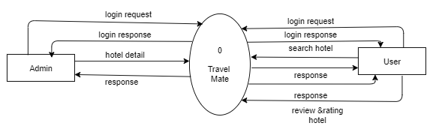

**FIG 4.1: Context Level Diagram**

## 4.2 Level 0 DFD

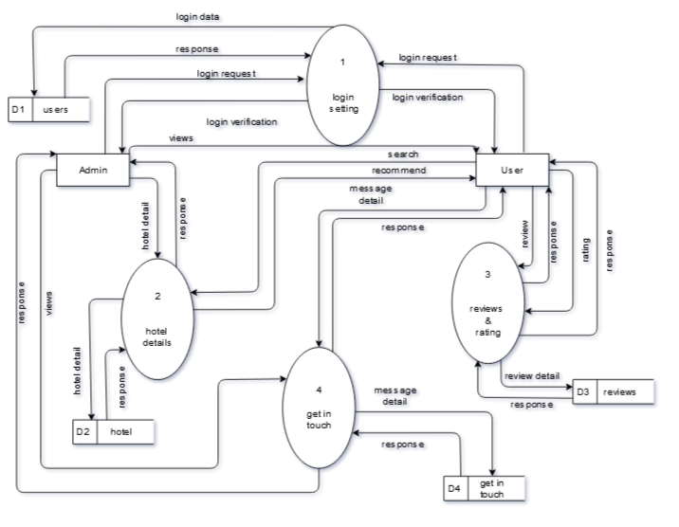

**FIG 4.2: Level 0 DFD**

## 4.3 Level 1 DFD

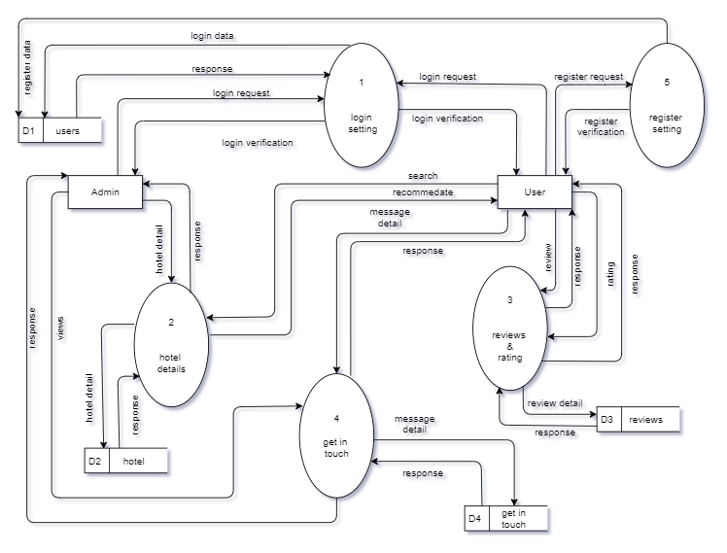

**FIG 4.3: Level 1 DFD**

## 4.4 Use Case Diagram

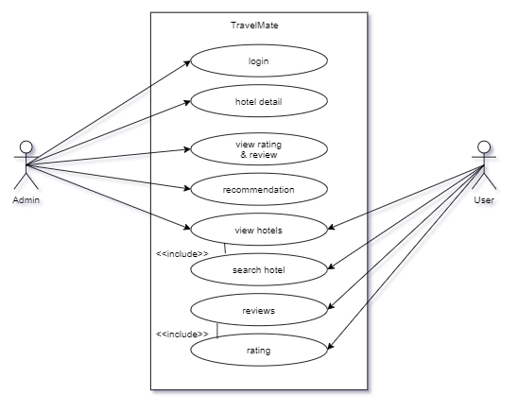

**FIG 4.4: Use Case Diagram**

## 4.5 ER Diagram

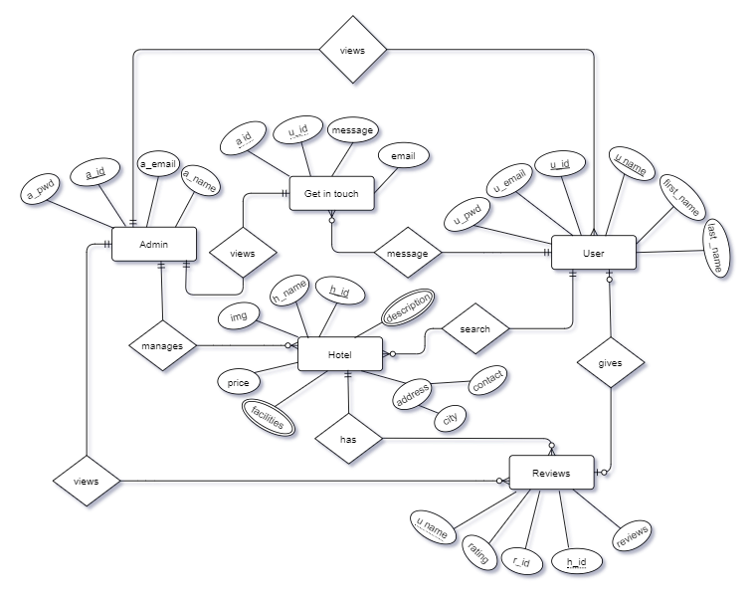

**FIG 4.5: ER Diagram**

# CHAPTER 5: SYSTEM DEVELOPMENT AND IMPLEMENTATION

## PROGRAMMING PLATFORM

* Windows platform

### FRONTEND PLATFORM

* HTML
* CSS, Materialize CSS
* JavaScript, jQuery

### BACKEND PLATFORM:

* PHP
* Database-MySQL

## OPERATING REQUIREMENT

The minimum requirement for the system to run are as follows:

### Hardware Details

* Minimum 1 GB RAM
* Working internet connection
* 2 GB or above hard drive
* Intel Dual Core Processor or higher

### Software Details

* Operating system: Window XP or Higher
* Web browser (Chrome, Firefox, Opera, etc.)

## Testing and Debugging

|  |  |  |
| --- | --- | --- |
| S.NO | Test Objectives | Results |
| 1 | Checking whether the programs runs or not. | Passed |
| 2 | To check whether login system works successfully or not. | Passed |
| 3 | To check whether program displays all menus and forms successfully or not. | Passed |
| 4 | To check if the hotel information is added, searched, updated and deleted successfully or not | passed |
| 5 | To check if the user rating and review information is added successfully or not | passed |
| 6 | To check whether user detail is updated successfully or not. | passed |

**Table 5.1 Testing and Debugging**

# CHAPTER 6: CONCLUSION AND FUTURE ENHANCEMENT

## 6.1 Project Limitation

* Requires internet connection.
* Platform dependent.

## 6.2 Conclusion

This project has been great opportunity for us to learn about web programming. It was a great time for us while making this project with support of our friends and teachers who supported us.

Using this system, researchers and travelers can get various information on hotel detail. This platform reduces time consumption, misunderstandings, and data repetition. This system recommends best hotel based on user input for better accommodation. With the use of system, exceptions are reduced and even terminated but the program is not complete by itself. There is still feature to implement for support and control.

## 6.3 Future Enhancement

* Implementation of Better Graphical user Interface
* Secured data and better Security
* Platform independent
* Making Web Application of Software to be used by everyone and easily Accessible
* More user friendly

# REFERENCES

The following references were used for the completion of the project.

Bayross, I. (2010).*Web enabled commercial applications development using HTML,Dhtml,Javascript,Perl Cgi*(4th ed).New Delhi: BPB Publication

<https://www.w3school.com/sql/>.

<https://www.php.net/>

<https://fontawesome.com/>

<https://materializecss.com/>

# APPENDIX

